Data summary following Quintette chat

Agnes Pelletier

Clayton Lamb

Rob Serrouya

July 14, 2023

**Goal:** Get QT report data into one place so census area and results can be compared during Seip-Pelletier transition, and decide on a method to estimate trend in QT 2008 to current.

**Seip and Jones 2008:**

2008 was first real QT estimate. Dale say 95 caribou without telemetry, and 8 of 14 available collars making an estimate of 166 animals. All 14 available collars were in HEWR. Dale also followed all missed collars and got a min count of 173.

Census are: The census area included the mountains between Kinuseo Creek to the south, and the Sukunka River to the north. We terminated the census at the top ends of watersheds near the height of the Rockies where the topography becomes very rugged and is seldom used by caribou in winter. The flight route (Figure 2) included areas that were most likely to be selected by caribou in winter based on radio- telemetry and caribou habitat modelling (Jones *et al*. 2007, Jones 2008). We did not survey Bullmoose Mountain because previous surveys (Seip 2002) and telemetry data indicated that caribou rarely use that area, and also we were low on fuel at that time.

RESULTS:

HEWR: We located and counted 95 caribou without using telemetry to find them (Table 1). These caribou included 8 of the 14 radio-collared caribou (57%). Thus, assuming we saw 57% of the total population, the estimated population size is 166 caribou, with a 95% confidence interval of 99-218. When we used radio-telemetry to locate the remaining collars, we counted an additional 78 caribou for a total minimum count of 173.

Extrapolation: none

**Seip and Jones 2013**

Census area: Each population census was conducted by aerially searching (from a Bell 206 helicopter) for caribou tracks and caribou in the subalpine and alpine zones within the typical winter range of each herd. When a group of caribou was located, we counted the number of adults and calves, and then used radio-telemetry to determine if any collared caribou were present within the group. After the survey was completed, we used telemetry to locate and count collared caribou that were missed during the survey to provide a minimum population count.

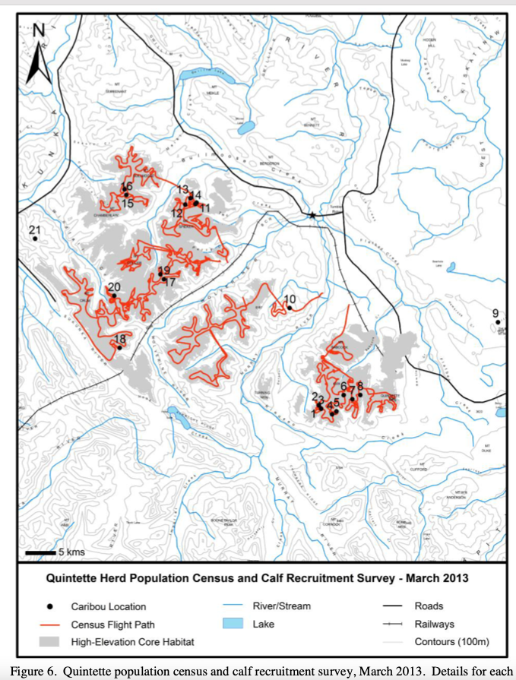

RESULTS:

HEWR: Within the census area we counted 83 caribou without using telemetry (Table 6). These caribou included 11 out of the 13 radio-collared caribou in the census area (85%). Thus, assuming we saw 85% of the population, the population estimate becomes 98 ± 21 (95% CIs, Lancia *et al.* 1996) caribou. Using telemetry to find the remaining two collars we counted an additional 17 caribou for a minimum count of 100 caribou within the census area. This brings the population estimate within the census area to 100 - 119 caribou.

Extrapolation: During the census, four of the 17 radio-collared Quintette caribou (24%) were outside of the census area, two in other alpine areas and two in low-elevation forest. Therefore, the estimate for the entire population when we correct for the 24% of the population that may have been outside the census area is 129 caribou (98 caribou/0.76). We counted an additional 14 caribou associated with 2 of the collars outside of the census area which provides a minimum count of 114 caribou for the total population.

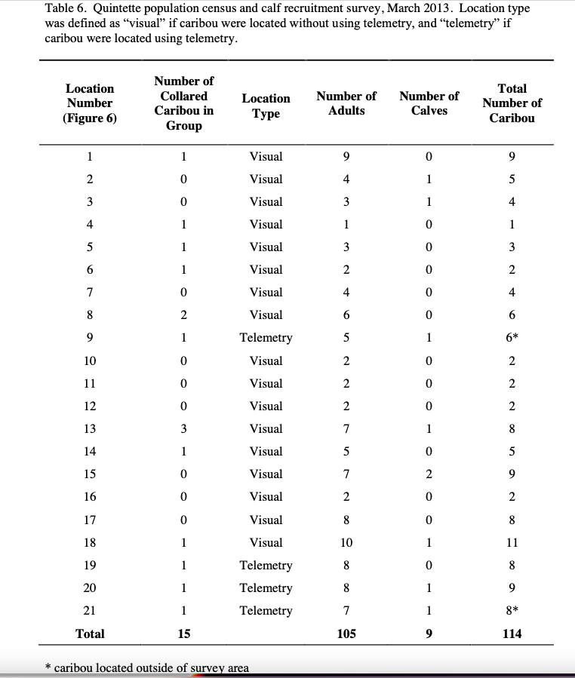

**Seip and Jones 2016**

Census area: On March 8 and 9, an aerial survey of the high-elevation winter range of the Quintette herd was conducted from helicopter (Figure 3).

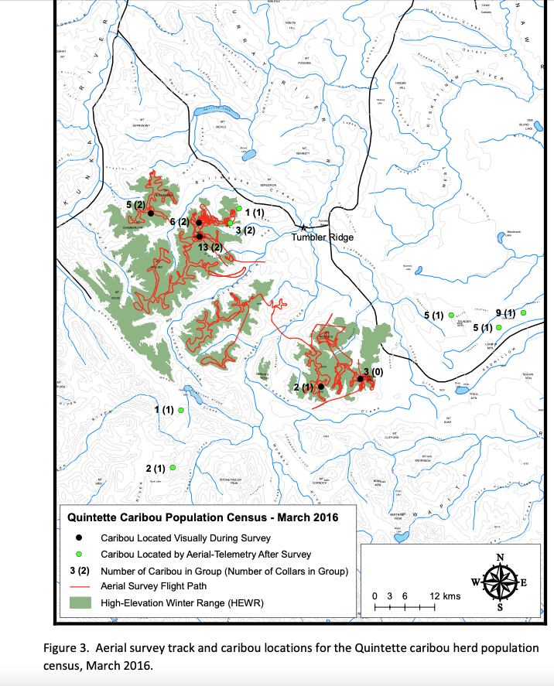

RESULTS

HEWR: During the census, a total of 29 caribou were counted within the high-elevation census area. Seven of the 10 collared caribou that were in the high-elevation census area were seen during the survey for a sightability of 70%. Correcting for sightability, the population estimate on the high-elevation census area was 41 caribou. The minimum count of caribou was 33 in the high-elevation census area.

Extrapolation: In addition, two collared caribou were outside the census area using low-elevation winter range, and three were using high-elevation winter range beyond the census area (Figure 3). Therefore we saw seven of the 15 collared caribou in the population for a sightability estimate of 47%, yielding an overall population estimate of 62 caribou. The minimum count of caribou was 39 in the overall population.

Seip and Jones 2019

Census Area: An aerial census of the high-elevation winter range for Quintette caribou was conducted on March 28 and 29, 2018. A route following alpine and subalpine habitat was flown by helicopter within the entire high-elevation winter range (Figure 4), with the exception of the Mt. Crum area. The Mt. Crum range is very rugged and rarely has caribou present during late winter. This area has not been included in previous censuses, except in 2013, when radio- collar data indicated presence of collared caribou. The flight route was recorded using a handheld GPS

RESULTS

HEWR: There were 49 caribou observed in the high-elevation winter range without the use of telemetry, and nine caribou counted using telemetry (Table 1). Therefore, the minimum number of Quintette caribou in the high-elevation winter range was 58.

During the census there were 16 caribou with functioning radio-collars known to be in the high- elevation winter range, and two radio-collared caribou known to be outside of the high- elevation winter range. At the completion of the census we had not observed four of the 16 radio-collared caribou known to be in the high-elevation winter range. 12 of the 16 radio-collared caribou (75%) known to be in the high-elevation winter range were found without the use of telemetry (Table 1). Therefore, the sightability correction factor was 1.33 (100/75) for the high-elevation winter range.

Extrapolation: The nine caribou counted outside of the high-elevation winter range results in a minimum count for the entire Quintette caribou herd of 67 animals (Table 1). Including the two radio-collared caribou that were outside of the high-elevation winter range, we observed 12 of the 18 radio-collared caribou (66.6%) during the population census. Therefore, the sightability correction factor was 1.5 (100/66.6) for the entire Quintette caribou range. Correcting for sightability results in a population estimate of 74 caribou in the entire Quintette caribou range.

**Pelletier and Seip 2019**

Census Area: an aerial census of the high-elevation winter range for Quintette caribou was conducted on April 8th and 9th, 2019. A route following alpine and subalpine habitat was flown by helicopter within the entire high-elevation winter range (Figure 3a), with the exception of the Mt. Crum area, which is very rugged and rarely has caribou present during late winter. This area has not been included in previous censuses, except in 2013, when radio-collar data indicated presence of collared caribou. The flight route was recorded using a handheld GPS.

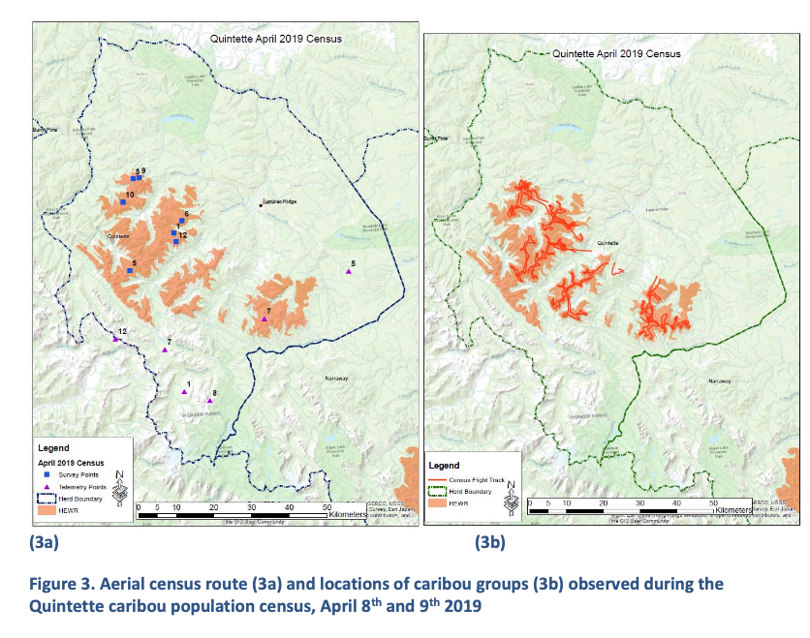

RESULTS

HEWR: there were 48 caribou observed without the use of telemetry (minimum count), and 7 caribou counted using telemetry, therefore, the total count was 55 (Table 1); 6 of 7 functioning radio collars (86%) were found without the use of telemetry (Table 1). Correcting for sightability results in a population estimate of 56 (48/0.86) caribou in the high-elevation winter range.

Extrapolation: 6 of 8 functioning radio collars (75%) were found during the survey (four newly

deployed collars were not included in the total collar count to avoid bias); Correcting for sightability results in a population estimate of 64 caribou (48/0.75) for the

entire Quintette range; The total count was 88 animals (55 in HEWR and 33 outside of the survey area). Even though the corrected population estimate indicates 64 animals, the total count provides the best indication of population size for 2019, since the animals were directly observed. This total count will be used to assess population trends.

The total count was 88 animals (55 in HEWR and 33 outside of the survey area). Even

though the corrected population estimate indicates 64 animals, the total count provides the best indication of population size for 2019, since the animals were directly observed. **This total count will be used to assess population trends.**

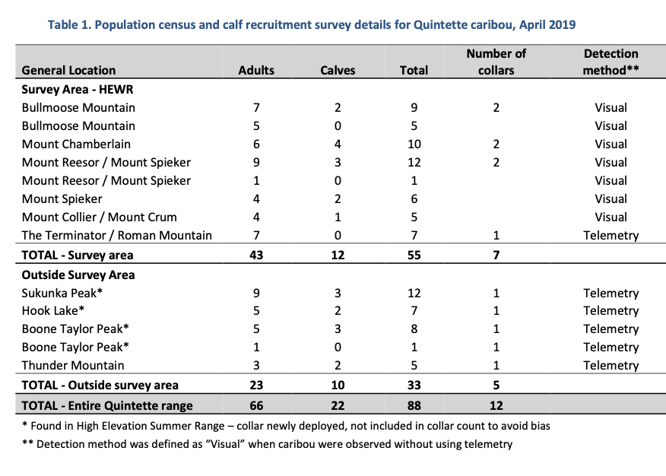

**Pelletier and Seip 2020**

Census area: An aerial census of the high elevation winter range (survey area) for Quintette caribou was conducted from February 24th to 27th, 2020. A survey following alpine and subalpine habitat was flown by helicopter within the entire high elevation winter range (Figure 3), except for the Mt. Crum area, which is very rugged and rarely has caribou present during late winter. This area is only included in the survey when early/late winter GPS data indicates the presence of caribou. The flight route was recorded using a handheld GPS.

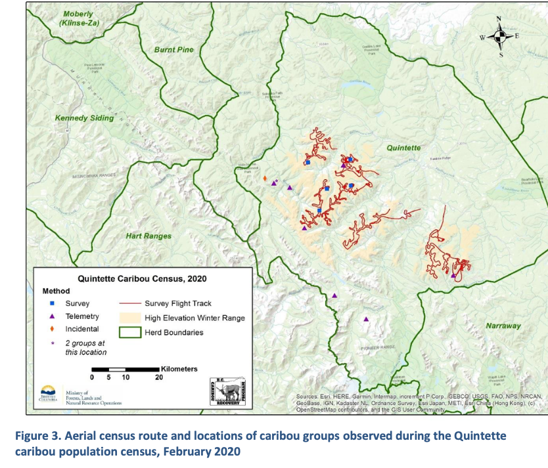

RESULTS

HEWR: there were 14 caribou (10 adults and 4 calves) observed without the use of telemetry (minimum count), and 3 caribou (2 adults and one calf) counted using telemetry, therefore, the total count was 17;

Extrapolation: a total of 47 animals were observed.

Results indicate that most animals may have been missed during the survey, rather than a population decline occurred. Two factors could explain the atypical winter distribution observed in 2020. **Since most animals were missed during the survey, these proposed population estimates are not reliable, and should not be used for trend analyses.**

**Pelletier and Watt 2021**

Census Area: This is where the census area deviates from Seip historical area

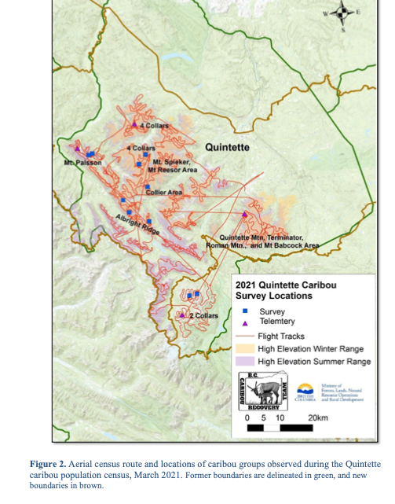

RESULTS

HEWR: there were 49 caribou (28 cows, 10 bulls, 1 unknown adult and 10 calves) observed without the use of telemetry, and 11 caribou (7 cow, 3 bulls and 1 calf) counted using telemetry, therefore, the minimum count was 60; 4 of 8 collars in HEWR were seen.

Extrapolation: Excluding Boone Taylor area, and only focusing on QT HEWR and HESR which Agnes suggested is most comparable to Dale’ counts (pers comm July 14, 2023), then 57 caribou were observed in the QT without use of telemetry. 6 of 11 collars were observed. The minimum count using telemetry was 71 caribou.

**‘**

**Pelletier and Watt 2022**

Census Area: An aerial census of the Quintette range was conducted from March 22nd to 25th 2022, under satisfactory survey conditions with good snow cover and good visibility during 73% of the survey time, and moderate to poor survey conditions during the remaining time. The majority of the survey was conducted during a single day in 9.7 hours of flight time to optimize a good weather window. The survey area included all high elevation areas, including high elevation winter and summer ranges, as well as the Boone Taylor / Shark’s Fin area west of Monkman Provincial Park, which was reassigned to Narraway in May 2021 (Government of British Columbia 2021a; Fig. 2). The Bearhole-Redwillow area (reassigned to Quintette in May 2021) was surveyed by the Government of Alberta and was not part of the survey area.

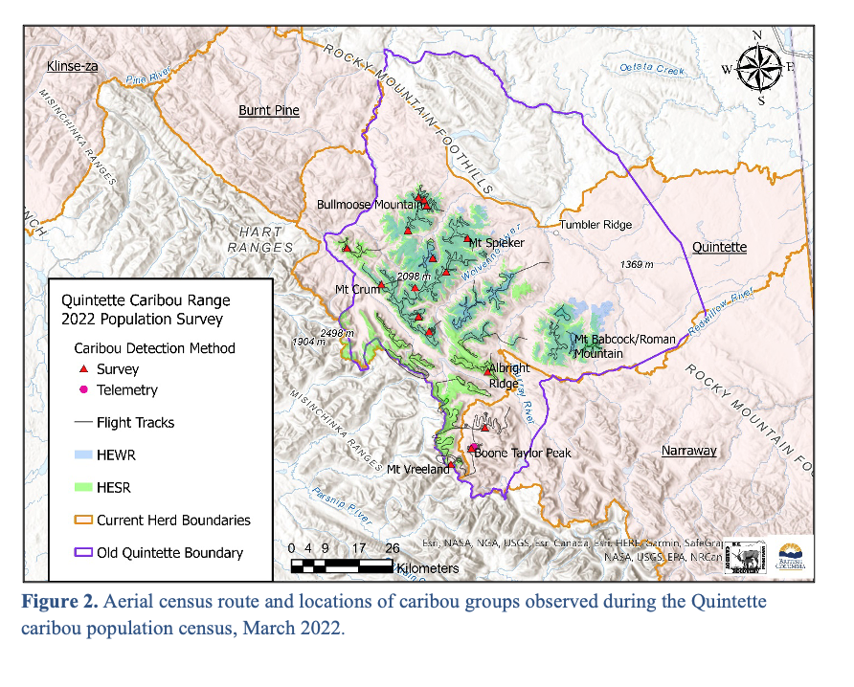

RESULTS

HEWR: 69 caribou counted and 9 of 9 collars found.

Extrapolation: Excluding Boone Taylor area, and only focusing on QT HEWR and HESR which Agnes suggested is most comparable to Dale’ counts (pers comm July 14, 2023), then 86 caribou were observed in the QT without use of telemetry. 13 of 13 collars were observed. The minimum count was thus 86 caribou.

**Pelletier 2023**

Census Area:

RESULTS

Census Area:

Extrapolation: